***Why Students should take up MSIS?***

**Claim**: Why students should take up MSIS program? Are you wondering if your business analysis career goals make sense financially? Simply looking, What companies MSIS student should target for to earn more!

**Evidence:** This Dashboard provides the audiences of the website an insight about the Average Salaries offered by Top companies to a Business Analyst. It can help students to know what are the top trending companies offering for a BA.

Data Source: <https://www.indeed.com/salaries/Business-Analyst-Salaries>

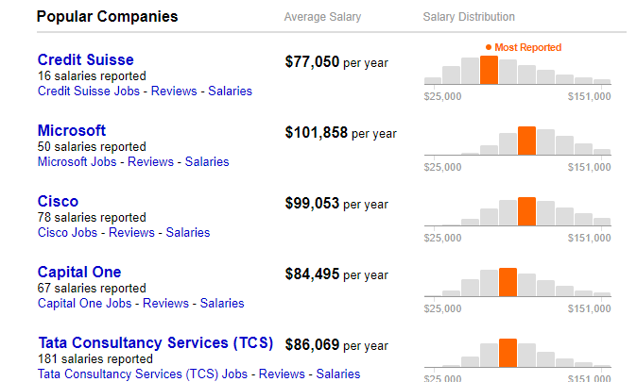

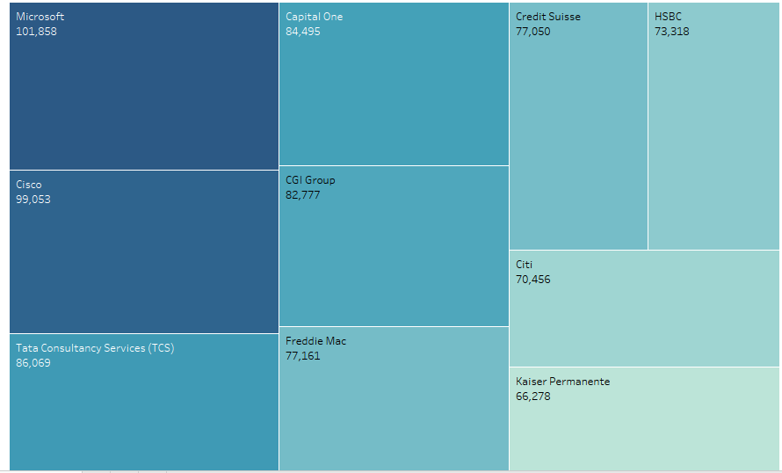

**Warrant**: As the website suggests that Microsoft i.e. $101,858 per year is paying the highest salaries to a BA in comparison to other companies. Overall, it shows Business Analysts are earning good money, which in turn increases the number of students taking up the MSIS program.

In an article <http://www.bridging-the-gap.com/business-analyst-salary/> , It clearly says that , In the US, the average business analyst salary is **$91,512**. This number rose significantly since the $82,493 average salary reported in 2010, and is more than double the median household income.

**Reservation**: The data I extracted is showing the data about general Business Analyst salaries, not specific to Santa Clara University graduates. I could have shown specifically, how much are the MSIS graduates earning as a Business Analyst.